Test and calibration reference document for the Atlas sensor suite

**Sensor Reference Documents** **1**

# 

# Sensor Reference Documents

The following documents contain information on the sensors and the sensor interface boards. The information includes storage, operating, and calibration procedures - the basic care and feeding of the sensors that will need to become part of the daily use of these sensor systems.

*Table 1: Sensor Reference documents*

| Sensor | Probe Datasheet | Interface Datasheet | [Modified Mega TWI code](https://drive.google.com/drive/folders/1Psr7MdnqTAKRTj3egFYFzSSMNDJwqV8I) | Notes | Data Documents, other links | Storage Solution (SS) / calibration solutions |
| --- | --- | --- | --- | --- | --- | --- |
| DO | [DO Probe](https://files.atlas-scientific.com/LG_DO_probe.pdf) | [DO EZO datasheet](https://files.atlas-scientific.com/DO_EZO_Datasheet.pdf) | [Do_Code](https://drive.google.com/drive/folders/1EqxbBd91KG8b2E-gcIgNzMFs0uUeehqK?usp=sharing) | Needs calibration in the lab. Compensation necessary in the field. Procedures in EZO datasheet. |  |  |
| ORP | [ORP Probe](https://files.atlas-scientific.com/orp_probe.pdf) | [ORP EZO Datasheet](https://files.atlas-scientific.com/ORP_EZO_Datasheet.pdf) | [Orp_Code](https://drive.google.com/drive/folders/1Psr7MdnqTAKRTj3egFYFzSSMNDJwqV8I?usp=sharing) | Needs calibration in the lab. No compensation req’d. Procedures in EZO datasheet. |  | SS req’d |
| pH | [pH Probe](https://files.atlas-scientific.com/pH_probe.pdf) | [Ph EZO Datasheet](https://files.atlas-scientific.com/pH_EZO_Datasheet.pdf) | [Ph_Code](https://drive.google.com/drive/folders/1zNlmxwSAjaoutUNs2tj-xZdu_--tn4jC) | Needs calibrated. Temperature compensation req’d in the field. Procedures in the EZO datasheet. | [Readings Doc](https://docs.google.com/document/d/1kuBjtr68250TKq6A5CdOdpyQT-ceDq_i5QQdlgRHGrw/edit) | SS req’d,  3xCS (pH = 4, 7, 10) |
| EC | [EC Probe](https://files.atlas-scientific.com/EC_K_1.0_probe.pdf) | [EC EZO Datasheet](https://files.atlas-scientific.com/EC_EZO_Datasheet.pdf) | [Ec_Code](https://drive.google.com/drive/folders/1o6r8_FemZtHYR5ABRJB3fBp7cbmKfMOg?usp=sharing) | Calibration is required - and somewhat complicated in that temperature compensation is required when calibrating. Temperature compensation req’d in the field. Procedures in the EZO datasheet. | [EC Accuracy graphs](https://files.atlas-scientific.com/conductivity_accuracy_graph.pdf) |  |
| RTD (temp) | [PT-1000 Temp probe](https://files.atlas-scientific.com/PT-1000-probe.pdf) | [RTD EZO Datasheet](https://files.atlas-scientific.com/EZO_RTD_Datasheet.pdf) | [Rtd_Comp](https://drive.google.com/drive/folders/1Fwu1ZbCUbtkVGgJaJaNEcIfLDab7Z304?usp=sharing) | Calibrate in boiling water. Note that water boils at 94.5 degrees C at the altitude of the Innovation Center. Procedures in the EZO datasheet. |  |  |
| Turbidity | [Turbidity sensor board ckt design](https://docs.google.com/document/d/16GMlUNbgq-OU39ZIzDr7a6In5NJqo6UcgynC9b5zo90/edit?usp=sharing) | [Sensor design tasks](https://docs.google.com/document/d/1ZhzHtK6CKekxFELb6nKkIBcgsUhLxm1X4uhkr62BGwg/edit?usp=sharing) |  | [Sensitivity analysis](https://docs.google.com/spreadsheets/d/1flnAnnFmPlZLAyD3je_cCqrFYG-jV2GHzlvq3TWtmHE/edit#gid=0) |  |  |
| Color | Arduino |  |  |  |  |  |
| Light intensity | Arduino |  |  |  |  |  |

Design considerations: [Water flow, mounting in pipes](https://files.atlas-scientific.com/connecting-probes-into-a-pipe.pdf).

# Calibration process

## Temperature Probe

* This calibration process comes from [the RTD Data Sheet](https://files.atlas-scientific.com/EZO_RTD_Datasheet.pdf) Page 12.
* The innovation center is at 4942’ of elevation. Water boils here at 95.04 degrees based on [this calculation](https://chemistrycalc.com/chemistry/boiling-point-altitude-calculator/#solve-boiling-point-altitude).
* Before proceeding to the lab, we tested the command to read a connected sensor with the sensor attached.
* The sensor properly connected and we read values that went up and down based on whether we were heating or cooling the probe.
* We used distilled water and boiled it, then inserted the probe. (See image below)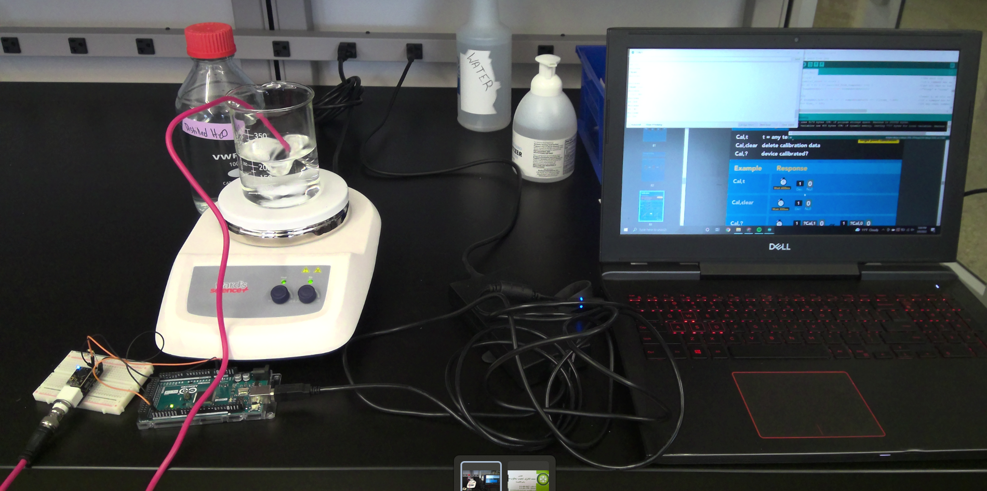
* For the first temperature probe, labeled A, the calibration data is:
  + Success
  + ?EXPORT,2,20
  + Success
  + 00CB21BF0000
  + Success
  + 0100283D
  + Success
  + *DONE
* Interpreting this for Temperature Probe A:
  + We should see TWO strings, representing TWENTY bytes of data.
  + What we actually see is two strings, representing 20 characters (bytes) of data.
    - Note: two one byte characters actually equals one real byte of data in memory. They use a confusing terminology here.
  + The calibration sting in this case is: 00 CB 21 BF 00 00 01 00 28 3D
  + The Calibration import commands when using temperature sensor A should be:
    - Import, 00CB21BF0000
    - Import, 0100283D
* For the second temperature probe (probe B) the calibration data is:
  + Success
  + ?EXPORT,2,20
  + Success
  + 00CD2CBF0000
  + Success
  + 01004F20
  + Success
  + *DONE
* Interpreting this for Temperature Probe B:
  + We should see TWO strings, representing TWENTY bytes of data, which we see.
  + The calibration sting in this case is: 00 CD 2C BF 00 00 01 00 4F 20
  + The Calibration import commands when using temperature sensor B should be:
    - Import, 00CD2CBF0000
    - Import, 01004F20
* These results need to be copied to the calibration tables below. They will also need to be put into the pre-field-trip checklist so that the sensor suite is calibrated for the sensors that are actually going into the field.

## ORP Probe

* Page 12-13 in the ORP [Manual](https://atlas-scientific.com/files/ORP_EZO_Datasheet.pdf)
* In the I2C mode we must continuously request readings. This is the “R” command - send it every second and wait for a reply.
* Find the 225 mV calibration solution pouch (Bottle Not Pouch) and have it nearby.
* Rinse of the sensor first (distilled water preferred).
* Open the 225 mV calibration pouch and insert sensor into the pouch. Take continuous measurements until the readings stabilize. The stabilization may have slight fluctuation in values.
* Once stabilized, issue the command “cal,225”
* In order to capture the calibration values (which may be needed in the future), use the export calibration command (see page 50). Cut and paste the output in this document.
* Orp A Calibration Data (12 characters, 6 bytes)
  + 4094C001C5C8
* ORP B Calibration data (12 characters, 6 bytes)
  + C0FDC0013C14
* Prior to using one of the above sensors, the calibration data must be uploaded into the Arduino using the IMport command for the sensor being used.
* Repeat this process once per year.

## DO Probe

* Pages 9-12 in the Dissolved Oxygen [Manual](https://files.atlas-scientific.com/DO_EZO_Datasheet.pdf)
* For now, we are doing the single point calibration (we do not need to be calibrated below 1mg/L). This procedure is described on page 10 of the manual.
* Connect the sensor to the EZO board and ensure connection to the arduino.
* Leave the sensor open to the air.
* Continuously request readings until the value stabilizes using the R command.
* Issue the CAL command once stabilized
* For sensor A, the readings stabilized.
* DO Calibration data for sensor A:
  + Note: The export commands failed. Not enough power??
* For sensor B, the readings did not stabilize.
  + Note: The export commands failed. Not enough power??
* We will contact Atles on these DO sensor issues. In the meantime, only use DO Sensor A, as sensor B appears to have issues.
* This recalibration can be performed in the field when needed - as long as the sensor is dry. (NOTE: DO not wipe it dry, let it air dry).

## pH probe

* This Calibration Comes from the Ph manual [Pages 11-13](https://files.atlas-scientific.com/pH_EZO_Datasheet.pdf)
* Continuously Take Readings
* The sequence of testing is pH7, then pH4, thenpH10.
* For 7.00
  + Began With Removing Prob From Storage Cap
  + Rinse Probe
  + Remove the top of Ph Pouch
  + Set the Ph Into pouch until Reading Stabilize
  + Solution Is Only Valid For 20 Minutes after Discord
  + Once Reading Stabilize Send Cal,Mid,7
* Onto 4.00
* The sequence of testing is pH7, then pH4, then pH10.
* For 4.00
  + Began With Removing Probe From Storage Cap
  + Rinse Probe
  + Remove the top of Ph Pouch
  + Set the Ph Into pouch until Reading Stabilize
  + Solution Is Only Valid For 20 Minutes after Discord
  + Once Reading Stabilize Send Cal,Mid,7

## EC Probe

* Calibration Comes from page 12-16
  + Two Point Calibration (plus dry calibration)
    - Solutions are
    - 12,880us Atlas Scientific
    - 80,000us Atlas Scientific
* Do not wet the probe before Calibration
* Set Probe Type to the right voltage k 1.0 is the default
  + We queried the EZO setting and it is set to k=1.0
* Cal Dry is the first one take a cal in the air
  + No Continuous Reading to set cal,dry
  + The command failed (pending) until Mark extended the command wait time for calibration to 2 seconds.
* Calibration Results
  + Cal Probe A Low (12,880uS)
    - Calibration fluid 23 degrees Celsius - no need to compensate (within 5 degrees)
    - Waited two minutes - Issued the Cal,low,12880 command. We queried the cal (Cal, ?), and were told it was calibrated to dry only (not a one point cal). This is an issue. It means the calibration did not take place.
    - We tried to do the second (high) calibration. Once settled, we issued the cal,high,80000 command. Cal,? Responded with “?cal,0”, again meaning the calibration did not take.
    - Tried the second sensor, same result.
    - Tried the second EZO board. Same result.
    - CRAIG TOOK THE ACTION TO CONTACT ATLAS

## Calibration results tables

Build table to collect calibration results